Grades 4 to 6 | English Language Arts and Arts Education

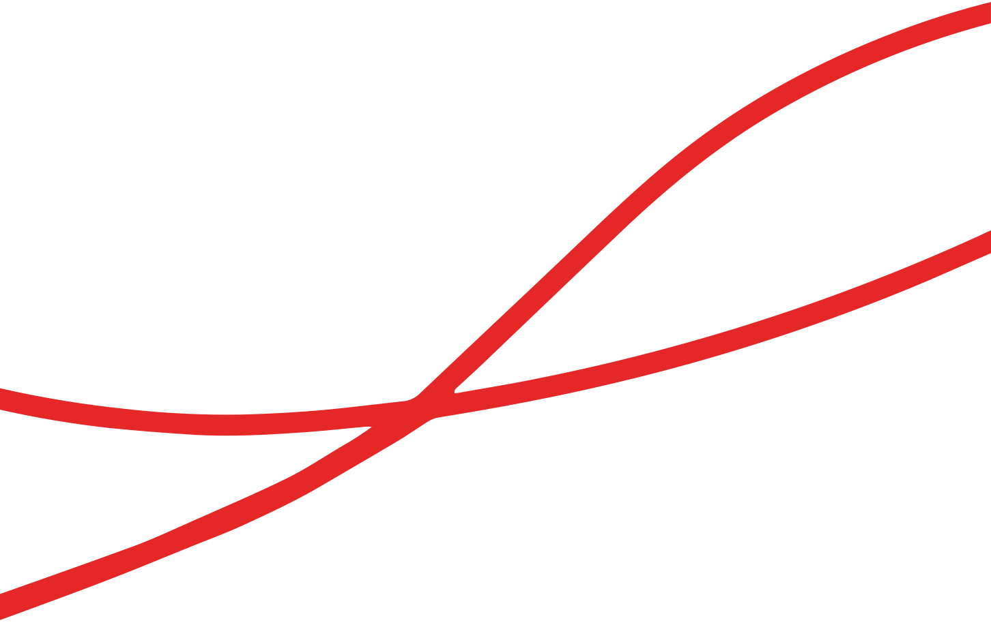
Activity Plan: Discovering, Uncovering and Celebrating Identity
Table of Contents

Overview 3
Big question 3
Activity description 3
Grades and curricular area(s) 3
Big ideas 3
Curricular competencies 4
Materials/Resources 4
Picture books 5
Other resources 5
Background information for teachers 6
Kick Off and Connect 6
Explore and Engage 8
Wrap-Up and Assess 9
Assessment 10
Extend and Transform 10
Visit the Saffron Threads website for more educational resources:
www.saffronthreads.ca

Overview

Big question
How do stories help me reflect on my identity and the identity of others?

Activity description
Students will engage in various inquiries around identity and explore how identity may be shared in their communities

Grades and curricular area(s)
- Grades 4 to 6
- English Language Arts (ELA) and Arts Education

Big ideas
 | English Language Arts (ELA) | Arts Education
Grade 4 | Exploring stories and other texts helps us understand ourselves and make connections to others and to the world. | Creative expression is a means to explore and share one’s identity within a community.
 | Language and text can be a source of creativity and joy. | Exploring works of art exposes us to diverse values, knowledge, and perspectives.
Grade 5 | Exploring stories and other texts helps us understand ourselves and make connections to others and to the world. | Engaging in creative expression and experiences expands people’s sense of identity and belonging.
 | Language and text can be a source of creativity and joy. | Works of art influence and are influenced by the world around us.
Grade 6 | Exploring stories and other texts helps us understand ourselves and make connections to others and to the world. | Engaging in creative expression and experiences expands people’s sense of identity and community.
 | Language and text can be a source of creativity and joy. | Experiencing art is a means to develop empathy for others’ perspectives and experiences.

Curricular competencies
 | English Language Arts (ELA) | Arts Education
Grade 4 | Recognize the role of language in personal, social, and cultural identity | Explore identity, place, culture, and belonging through arts experiences
 | Demonstrate awareness of the oral tradition in First Peoples cultures | Interpret and communicate ideas using symbolism to express meaning through the arts
 | Use oral storytelling processes
Grade 5 | Explain the role of language in personal, social, and cultural identity | Explore connections to identity, place, culture, and belonging through creative expression
 | Demonstrate awareness of the oral tradition in First Peoples cultures | Interpret and communicate ideas using symbols and elements to express meaning through the arts
 | Use oral storytelling processes
Grade 6 | Recognize how language constructs personal, social, and cultural identity | Explore relationships between identity, place, culture, society, and belonging through the arts
 | Recognize and appreciate the role of story, narrative, and oral tradition in expressing First Peoples perspectives, values, beliefs, and points of view | Interpret and communicate ideas using symbols and elements to express meaning through the arts
 | Use and experiment with oral storytelling processes

Materials/Resources
- Social Identity Wheel
- Personal Identity Wheel
- Teachings by the Medicine Wheel by Nicole Bell
- Cardstock paper for identity collages
- Magazines, newspapers, photos, and other treasures for collaging
- Drawing paper for identity images/symbols or South Asian images
- Scissors, glue, felt markers/pencil crayons/gel pens for collages
- Student journals

Picture books
Title | Author |  | Topic |  | Notes
Always Anjali |  | Sheetal Sheth |  | names, identity, and empowerment through art |  | optional read-aloud video
Bilal Cooks Dal |  | Aisha Saeed |  | challenging stereotypes, cultural cuisine, and nutrition
Fauja Singh Keeps Going |  | Simran Jeet Singh |  | perseverance, identity, elders |  | optional read-aloud video
My Name Is Bilal |  | Asma Mobin-Uddin |  | names and identity
Stories for South Asian Super Girls |  | Raj Kaur Khaira |  | positive role models
The Boy and the Bindi |  | Vivek Shraya |  | gender expression
The Many Colors of Harpreet Singh |  | Supriya Kelkar |  | cultural identity

Other resources
- Art in Motion | Exquisite Corpse with Sandeep Johal, Surrey Art Gallery (video, 6:42)
- Identity, Learning for Justice (identity and empathy, immigration)
- Identity Artifacts Museum, Learning for Justice
- Intersectionality 101, Learning for Justice (video, 3:03)
- In the Wake of the Komagata Maru, Surrey Art Gallery
- Interviewing Techniques, Tools for Thought
- Nep Sidhu: Shadows in the Major Seventh, Surrey Art Gallery (exhibit no longer active; mirrored name design/personal symbology)
- Sandeep Johal (artist website)
- Spectacular Sangeet, Surrey Art Gallery (exhibit no longer active; puppet dancers)
- Storytelling: Oral Traditions, PBS Learning Media
- Street Art with Sandeep Johal, Inspired British Columbia (video, 7:32)

Background information for teachers
It is important to create a safe environment in which students feel free to explore and uncover their identity. Discuss guidelines on how to explore ideas in respectful ways. Tell students they are going to learn about South Asian culture and unpack what they know, what they want to know, and what they learned after reading different books. Ask students to reference the picture book stories at first to avoid any stereotypes.
Before teaching this lesson, you may want to explore anti-racism education resources, such as:
- Learning for Justice (website)
- Reading Picture Books with Children through a Race-Conscious Lens, EmbraceRace
- Tips for Drawing Across Color Lines with Kids, EmbraceRace
- Discovering My Identity, Learning for Justice

Kick Off and Connect

Pair up students and ask them to take turns asking each other the question, “Who are you?” They must respond with a different answer each time. Time the students for one-minute intervals. Teachers may also want to model this to the class by having students take turns asking the question “Who are you?” to them. (Adapted from Cultivating Genius: An Equity Framework for Culturally and Historically Responsive Literacy, Gholdy Muhammad, p. 73.)

With the whole class, brainstorm a list of categories that help people define themselves. Several of these may have been discussed in the previous activity. Possibilities include race, religion, ethnicity, nationality, gender, ability, language, culture and favourite hobbies.

Discuss the term “identity” with students. (Depending on the class, you may want to start by asking them to define it, or you could share your own definition.) Note for students that the ideas they discussed in the previous step make up a part of their identity.

Think-Pair-Share discussion: Provide students with two questions to think about, discuss with a partner, and then share with the class:
- How does it feel when my identity is not represented?
- How does it feel when my identity is attacked or made fun of?

Tell students they will be exploring South Asian cultures through stories. Show on a map the countries in South Asia: India, Pakistan, Bangladesh, Sri Lanka, Bhutan, Nepal, and the Maldives.

Individually, in pairs or as a class, have students complete a Know-Wonder-Learn (KWL) chart about South Asian culture and identity.

Read one or more of the books listed in the Materials/Resource section or show the video(s) of the book being read aloud.

As a class, use the main character from one of the stories to identify social and/or personal identity characteristics of the character. You may use the Social Identity Wheel handout, Personal Identity Wheel handout, and/or another template/format. If the stories don’t cover all elements that your class discusses, have students make predictions and explain why, based on what they know of the character.
Note: Higher grades may also want to touch on intersectionality. Intersectionality 101 (Learning for Justice, video, 3:03) explains the cumulative effect of multiple identities on our lived experience.

Explain that our names are also important to our identity. Go back to the story you read to the class and discuss the South Asian names of the characters. Have students research the meaning of the name(s) in the story. Extend this activity by having students research one of their own names (first, middle, last, or a nickname).

In pairs or small groups, have students reflect on what exploring South Asian culture has revealed to them about their own identities.

Explore and Engage

Discuss symbolism. Some questions to ask students:
- What is a symbol?
- How are symbols connected to our identity?
- How are symbols connected to culture?
You can show them some examples of South Asian Symbols.

Have students brainstorm elements of their own personal and/or social identity. This can be done either in a mind map or using the Personal Identity Wheel or Social Identity Wheel templates.

Connect with Indigenous wisdom: Show an image of a Medicine Wheel that shows the spiritual, physical, emotional, and mental aspects of the human experience. You may include images to represent the Medicine Wheel or the four parts of human experience. Ask students how they would depict each aspect of the Medicine Wheel for themselves.

Tell students they will be creating identity collages, a composition of different elements that they feel represents their identity. Encourage them to think about themselves, their interests and the different parts of their identity discussed previously.

As a class, discuss the identity collage assessment criteria. Students should include at least five parts of their identity and design the collage in a creative way. They can write the meaning of the images on the back of their board. Share the Identity Collage Self-Assessment so that students are aware of the learning intentions and criteria ahead of time.

Students could use words and images from magazines as well as photos, drawings, digital imagery, other print-based media, newspapers, stickers, and other treasures to create their identity collage. They could also print out digital Creative Commons licensed images if they prefer (Creative Commons or Unsplash). Alternatively, students could draw their symbols, imagery and so on.
- If students are unsure about what to do, encourage them to flip through magazines/images and cut out the images that pop out for them. This is how they can uncover their hidden symbology.
Students should avoid adding their names to their collage to keep the collage anonymous for the gallery walk. Students will be encouraged to display their collages on their desks after the activity, so ensure they know this in advance. Students are welcome to draw specific images that resonate with them.

Wrap-Up and Assess

Identity collage gallery walk: Have students do an anonymous gallery walk to look at all the collages. What can they infer about the artist? Do they think they know who it belongs to? Suggest using sentence stems such as:
- I think they like…
- I wonder if they used _____ because...
- I think this could be…
- It is interesting that _____ is used….

Emphasize that we can make inferences and guesses about people’s identity, but it is best to ask questions and explore our curiosity rather than make assumptions.

Art gallery celebration: Have students display their finished collages on their desks. Encourage them to walk around and write a compliment on the comment sheet beside the artist’s collage. Teaching students to comment on the elements of art that they appreciate helps them to build community and strengthen identity.
For example, I really like how you represented your identity as an activist with a strong fist in the air. The symbolism is very powerful! I like that you chose a dove to represent your belief in world peace.

Have students answer the following questions in their journals:
- What surprised you about the identity activities?
- What did you learn that you didn’t know before?
- Number the parts of your identity, from 1 to 10, from most important to least important to you.
- Why did you give those ratings?
- What vision of identity do you want to nurture within yourself?

Assessment

Conference with students to ask questions and determine their understanding.

Have students complete the Identity Collage Self-Assessment.

Extend and Transform

Lead students through a guided inquiry about a South Asian Canadian artist of your choice or from the book Stories for South Asian Super Girls, by Raj Kaur Khaira. (You may also choose to focus on artist Sandeep Johal, who illustrated Stories for South Asian Super Girls.)
- With the class, co-create a question-and-action plan about the artist. For each question they develop, they should indicate what they will do to try and find the answers.
For example: What themes does Sandeep Johal address in her art? How might I create art in Sandeep Johal’s style? What message(s) is she expressing in her murals and other art pieces?
- Have students make a plan to watch videos, read about the artist’s life and artistic style, and represent their learning in some way. Suggested videos:
- Art in Motion | Exquisite Corpse with Sandeep Johal (6:42)
- Street art with Sandeep Johal (7:32)
- Students demonstrate and share their learning with the class (video, artwork, TED talk, etc.) and reflect on the process.

Introduce the concept of oral traditions to the class and explain that students will be sharing a story with the class. They can choose to tell a personal story that shaped who they are, or they can interview a parent/caregiver/adult and retell the story. For example, they may want to bring a special object or heirloom to focus on. They will be using oral storytelling methods to share their story with the class.
Questions to guide their oral story (interview or brainstorm process):
- Why is this story a powerful one to share?
- Are there any significant objects in the story?
- Who are the characters?
- Where does this story take place?
- When does the story take place?
- What are the events in the story?
- What is the problem?
- How is the problem resolved?

Create an Identity Artifacts Museum.

Create self-portraits with personal symbology.

Know Wonder Learn Chart
Know | Wonder | Learn
Identity Collage Self-Assessment
Circle the number that reflects your experience.
I can identify the different parts of my identity (a minimum of 5 in the collage). | 1 | 2 | 3 | 4
 | Beginning | Developing | Proficient | Extending
I can describe the parts of my identity that are most important to me and why. | 1 | 2 | 3 | 4
 | Beginning | Developing | Proficient | Extending
I can use at least 4 or 5 different media to artistically express my identity (magazine images, drawings, word cutouts, stickers, other treasures). | 1 | 2 | 3 | 4
 | Beginning | Developing | Proficient | Extending
I can use elements of art (line, colour, texture, shape, form, tone) to creatively represent my identity. | 1 | 2 | 3 | 4
 | Beginning | Developing | Proficient | Extending
I can identify and represent my personal symbols in my collage art and explain why they are important to me. | 1 | 2 | 3 | 4
 | Beginning | Developing | Proficient | Extending

