Question |  |  | Answer
1 | Knows why five is a significant number in some South Asian cultures |  | Sikhs have five sacred symbols 5K’s panj kakar; there are five elements in the universe according to Hindu cosmology; there are five Pillars of Islam, and prayers are recited five times every day.
2 | Knows where the concept of zero was discovered |  | The modern equivalent of Zero comes from the Hindu astronomer and mathematician Brahmagupta in 628.
3 | Knows how much one lakh and one crore is |  | - 1 lakh = 100,000  - 1 crore = 10,000,000
4 | Knows the name of a South Asian mathematician or scientist |  | Examples:  - Srinivasa Ramanujan (mathematician, 1887-1920)  - C.V. Raman (physicist, 1888-1970)  - Har Gobind Khorana (biochemist, Nobel Prize laureate, 1922-2011)  - A.P.J. Abdul Kalam (aerospace scientist, 1931-2015)  - Shakuntala Devi (mathematician, 1929-2013)
5 | Can calculate how much 1 INR (Indian rupee) is worth in CDN dollars, if 60 INR are worth CDN$1 |  | CDN$0.017 or 1.7¢
6 | Can identify/count the number of circles in this design: | 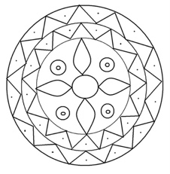 | 12
7 | Likes to eat pie (find out their favourite flavour) or knows the value of π (pi) to 10 decimal places |  | 3.1415926535

