Grades K to 3 | Physical and Health Education

Activity Plan: Brain Breaks
Table of Contents

Overview 3
Big question 3
Activity description 3
Grades and curricular area(s) 3
Big ideas 3
Curricular competencies 3
Materials/Resources 4
Books 4
Meditation videos 4
Templates 4
Kick Off and Connect 4
Explore and Engage 6
Wrap-Up and Assess 6
Assessment 7
Extend and Transform 8
Yoga activities 8
Visit the Saffron Threads website for more educational resources:
www.saffronthreads.ca

Overview

Big question
How can you prepare your brain for learning?

Activity description
Students will inquire about strategies to regulate their mind and body.

Grades and curricular area(s)
- Kindergarten to Grade 3
- Physical and Health Education (PHE)

Big ideas
 | Physical and Health Education (PHE)
Kindergarten | Good health comprises physical, mental, and emotional well-being.
Grade 1
Grade 2
Grade 3

Curricular competencies
 | Physical and Health Education (PHE)
Kindergarten | Students are able to identify and describe practices that promote mental well-being
Grade 1
Grade 2
Grade 3

Materials/Resources

Books
Title | Author | Notes
Breathe Like a Bear | Kira Willey | Optional read-aloud video
Finding Om | Rashmi Bismark | Optional read-aloud video
I Am Peace: A Book of Mindfulness | Susan Verde | Optional read-aloud video
Meena’s Mindful Moment | Tina Athaide
Mindful Monkey, Happy Panda | Lauren Alderfer
Moody Cow Meditates | Kerry MacLean
My Magic Breath | Nick Ortner and  Alison Taylor
The Lemonade Hurricane: A Story of Mindfulness and Meditation | Licia Morelli

Meditation videos
- Easy Mantra Meditation for Kids (1:33)
- Rainbow Relaxation: Mindfulness for Children (3:46)
- Learn to Bring Down Stress: Guided Meditation for Kids (3:27)
- Balloon (Peace Out: Guided Meditation) (6:22)
- Starfish (Peace Out: Guided Meditation) (5:59)

Templates
- My Three Brain Break Strategies

Kick Off and Connect

Class discussion:
- At school, how do we know that our bodies and minds are ready to learn?
- What are some indicators that our bodies are not ready to learn?
- What activities can you do to feel ready to learn?

Read one of the books suggested or show the class a video of the books being read aloud (see Materials/Resources).

As a class, discuss the story (book or video) using these questions:
- What is meditation?
- Students may not be familiar with meditation, but many will be familiar with calming breaths or relaxation breathing.
- What places in the world do you think meditation came from? (India, China, Japan, Tibet, and other Asian countries)
- Do you meditate? Do you know anyone who meditates?
- How do you think people feel after meditating?

Engage students in a meditation exercise by using a breathing activity video (see Materials/Resources) or by seating students on the carpet in a comfortable position and guiding them through deep breathing.

As a class, discuss how students feel after the meditation exercise and why meditation is helpful and important.
- There are many ways to calm our bodies down.
- Sometimes we may want to try a different strategy.

Explore and Engage

Brainstorm calming strategies as a class. Ideas might include:

- Meditate
- Go for a walk
- Do Jumping Jacks
- Dance
- Stretch
- Run
- Read
- Take small sips of water
- Take deep breaths
- Find a quiet space
- Think happy thoughts
- Listen to music
- Play with blocks
- Pat a pet
- Count
- Hug a stuffed toy
- Play with playdough
- Listen to calming music
- Dim lights
- Do yoga
- Look out the window
- Go outside

Have students choose their three favourite calming strategies and create a small poster to keep on their desk. Students can create this from scratch or use the My Three Brain Break Strategies template.
- Grades K to 1: Students can illustrate their strategies
- Grades 2 to 3: Students can illustrate and describe/name their strategies
Students can illustrate each strategy and use the poster as a reminder of things they can try when they are not focused for learning.

Wrap-Up and Assess

Ask students how they currently feel. Share how you currently feel.

As a class, do a guided meditation, using a resource such as:
- Learn to Bring Down Stress: Guided Meditation for Kids (3:27)
- Balloon (Peace Out: Guided Meditation) (6:22)
- Starfish (Peace Out: Guided Meditation) (5:59)

Ask students how they feel after meditating. Was this similar to something they’ve done before?

As a class, discuss:
- How do you know if your brain break is working?
- What should you do if it’s not working?

Assessment
You may choose to use a single-point rubric, a picture-based self-reflection, or another assessment tool.

Sample single-point rubric
Grows  Things I can work on | Criteria | Glows  Things I did well
 | I focused and listened during the meditative exercise.
 | I illustrated the three strategies that I think will work best for me.
 | I reflected on how I felt before and after meditation.

Sample reflection
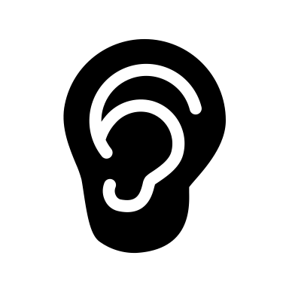
I focused and listened during the meditative exercise.
I illustrated the three strategies that I think will work best for me.
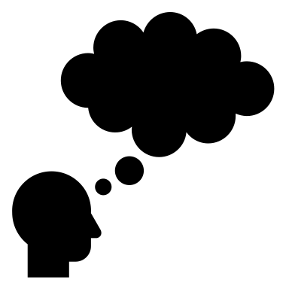
I reflected on how I felt before and after meditation.

Extend and Transform
- Yoga is like a physical meditation. Ask students:
- Do you know what yoga is?
- Do you know anyone who does yoga?
- Have you ever done yoga?
- Do yoga as a class. Ask students:
- How does yoga feel similar or different to meditation?

Yoga activities
- Yoga and Mindfulness for Kids: Outside in the Woods (38:30)
- Yoga for Kids! (25:04)
- Yoga for Kids with Animals (4:12)

My Three Brain Break Strategies

